**Function of tumor suppressor ATRX/DAXX/H3.3 chromatin**

**remodeling complex in preserving epigenomic and genomic stability**

**Background**

Histone variant H3.3 is a ‘replacement’ histone in dynamic chromatin remodeling processes throughout the genome, and the death domain-associated protein 6 (DAXX) is an H3.3 variant-specific histone chaperone that deposits H3.3 at heterochromatic (silenced) regions including telomeres, G-rich tandem repeats and retrotransposons. ATRX is a SNF-2 family chromatin remodeling ATPase that has been extensively studied in the context of the Alpha Thalassemia/mental retardation X-linked syndrome (ATR-X). The death domain-associated protein 6 (DAXX) forms a complex with ATRX, and recent studies have functionally linked this complex to the deposition of a specialized histone H3 family member, the H3.3 variant, at heterochromatic regions of the genome including telomeres, G-rich tandem repeats and retrotransposons.

G-quadruplexes (G4s) are nucleic acid secondary structures that form within G-rich DNA sequences. G4 formation can affect chromatin architecture and gene regulation and has been associated with genomic instability, genetic diseases and cancer progression. DNA sequences that can form G4s have been found in regions with biological significance, such as human telomeres and oncogene-promoter regions. In general, G4s can be resolved (unwound) by the evolved mechanisms of the cells. Double-stranded breaks (DSBs) may form whether G4s are not resolved in the process of replication, thereby inducing genomic instability. Therefore, we will correlate the formation of G4s with the occurrence of DNA double strand breaks (DSBs) to study **the function of ATRX-DAXX-H3.3 complex in the resolution of G4s.**

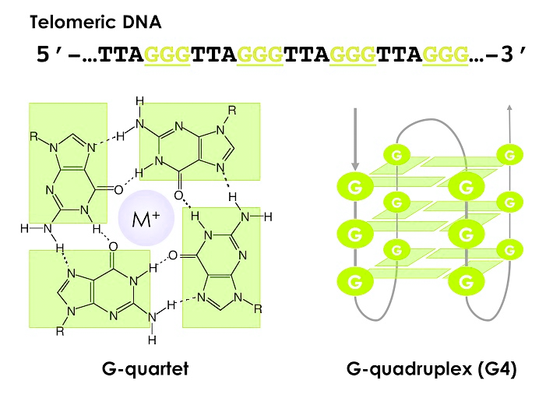

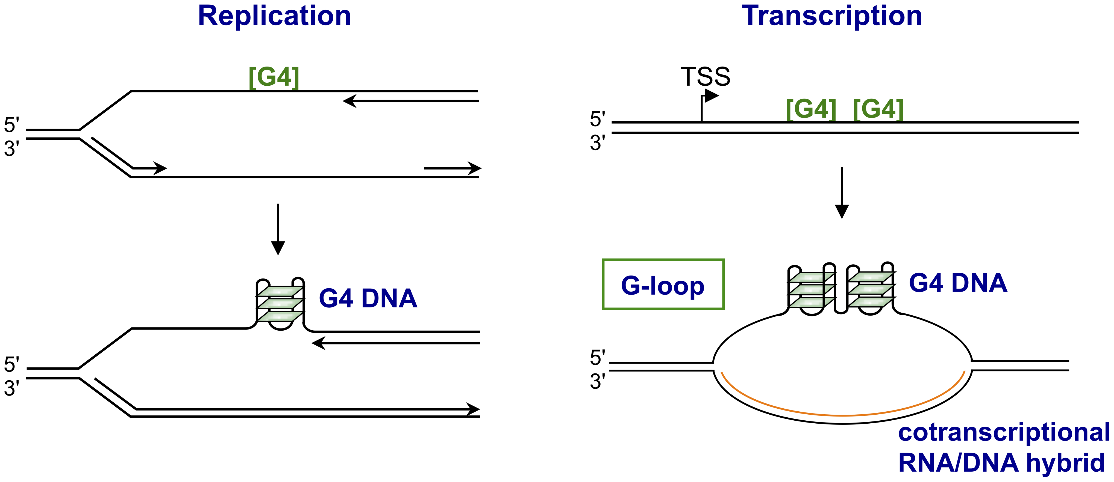

DNA Damage

**Aims**

In this study, we will investigate the genome-wide occurrence of DSBs, and identify whether the DSBs are significantly increased in H3.3KO, ATRX KO and DAXX KO cells compared to WT in G-rich regions.

**Materials and methods**

**Cell lines:** H3.3 WT, H3.3 KO (**same background**)

ATRX/DAXX WT (WT26), ATRX KO, DAXX KO (**same background**)

In this experiment, a new method for genome-wide mapping of DSBs (Breaks Labeling In Situ and Sequencing – BLISS) was used.

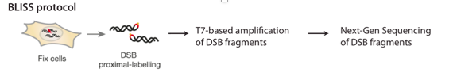

**Quality control of library on bioanalyzer**

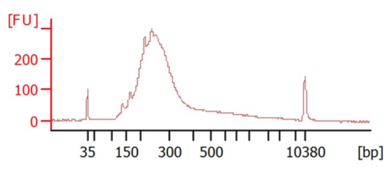

**Runs chart**

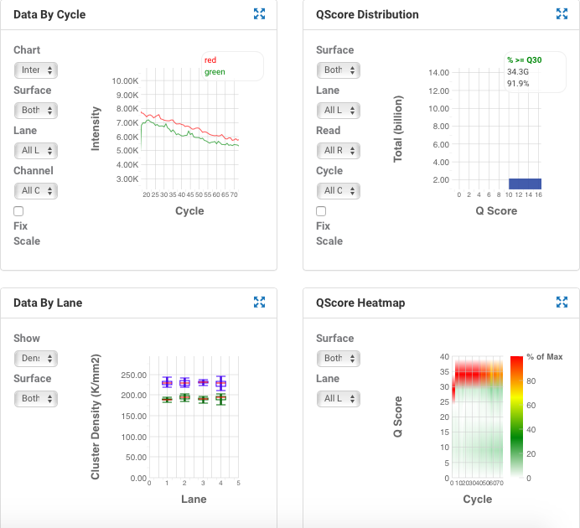

**Dataset:**

AVG %Q30: 92.07%

5 demultiplexed fastq files.